Sciconnect
Water cycle
- What is water
  - Oxygen is more electronegative-> water is polar
  - Water is universal solvent
  - Water can hydrogen bond
  - Ice is less dense than water-> hydrogen bonds are holding all the molecules apart-> good for aquatic organism
  - High specific heat-> energy required to change phase of substance, evaporate-> strong bonds from HBs-> water makes temps less extreme-> weather regulating 4.184 J/ g deg C, doesnt change temp easily
- Fresh water
  - Measure of salinity
  - Briny water (50+ ppt), saline water (30 ppt), brackish water (0.5 ppt), fresh water (0 ppt)
- Water budgets
  - Water budget- sum of all the ways water enters or exits a specific reservoir (affects how much water is stored at given time)
  - 3 fluxes-> evaporation, runoff, precipitation
  - Water inflow- water outflow= change in stored water
  - 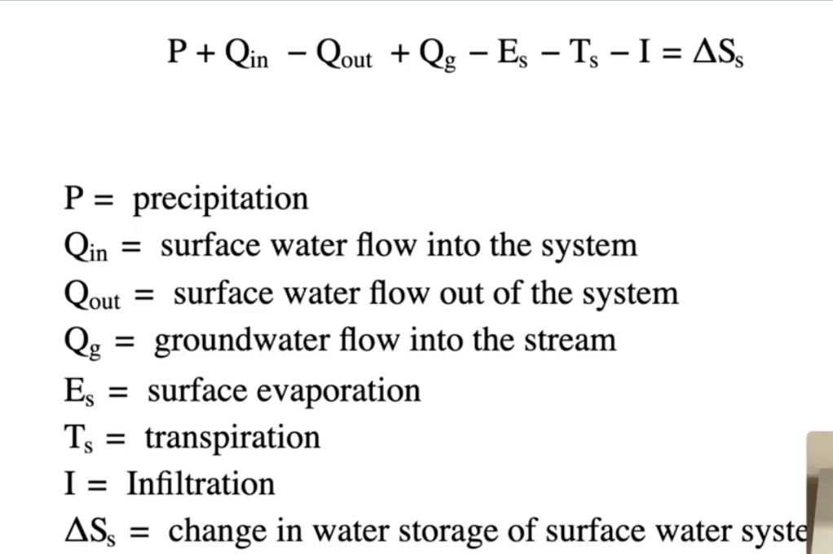
  - 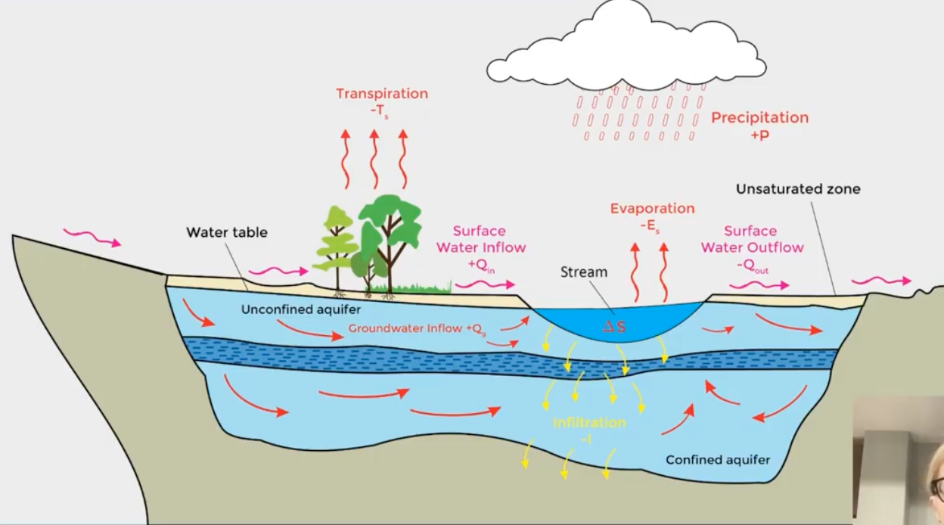
- Residence time
  - How long a water molecule stays in a reservoir on average
  - 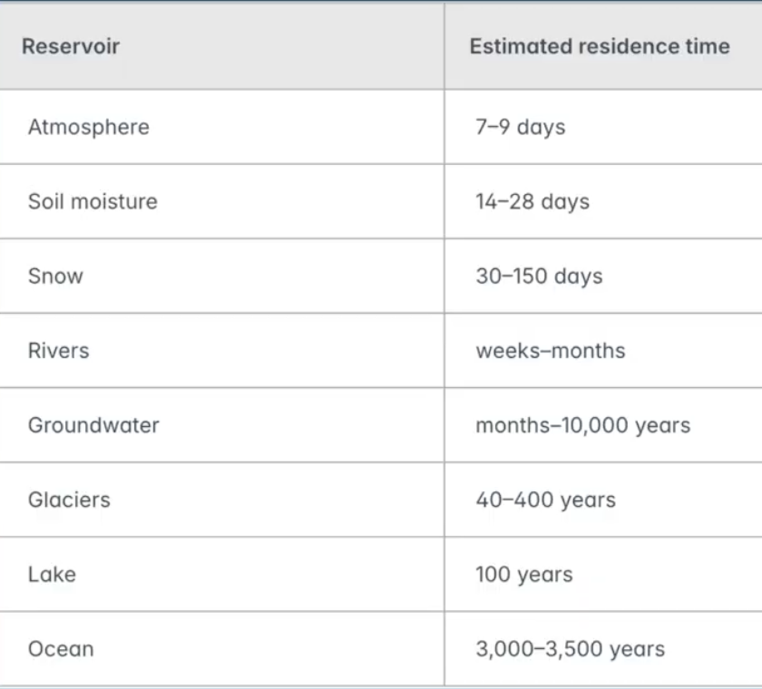
    - Depends on size of reservoir and how fast the fluxes are
  - 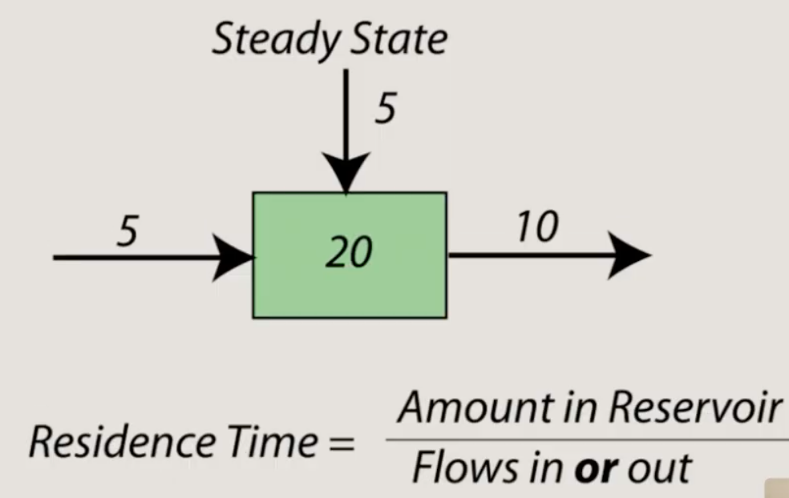
    - Need to assume steady state (same amount going in as out-> makes sure that size of reservoir doesn’t change)
  - Storage reservoirs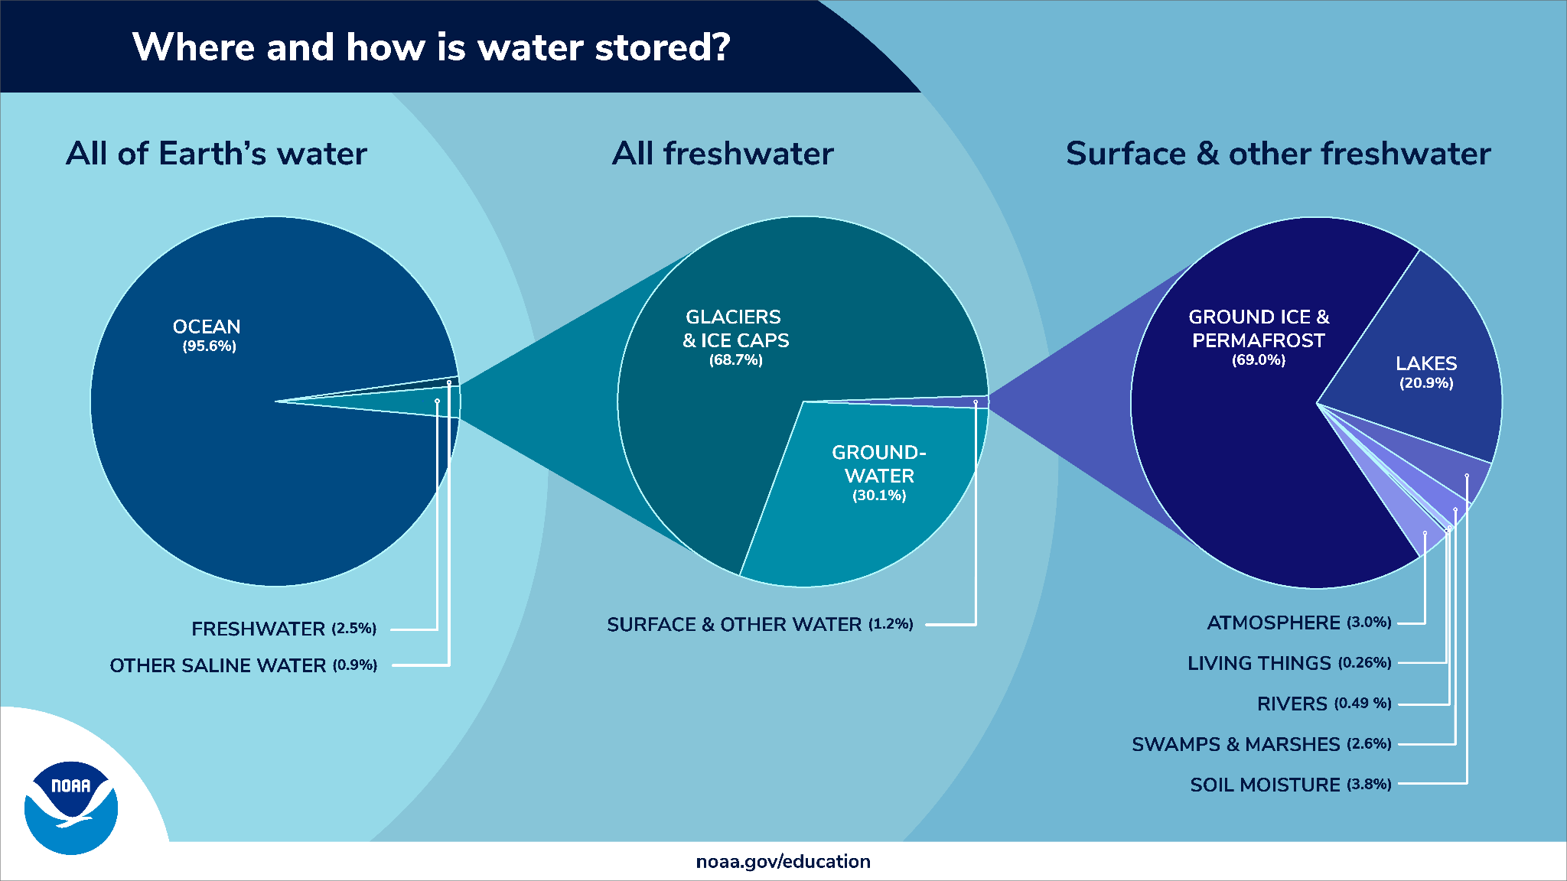
    - 2.5% of all water is freshwater, 97.5% is salt water
      - 68% or freshwater frozen (glaciers, icecaps, most is inaccessible for drinking water)
      - 30% ground water (all over the world, not easily accessible)
      - 0.25% rivers/lakes/wetlands, most of human accessible
      - Less than 1% permafrost/ground ice
  - Water cycle
    - Movement of water around earth, no beginning or end
    - Reservoirs
      - Store water, lake, atmosphere, ocean
    - Fluxes
      - How water moves between reservoirs, rain, phase changes
    - 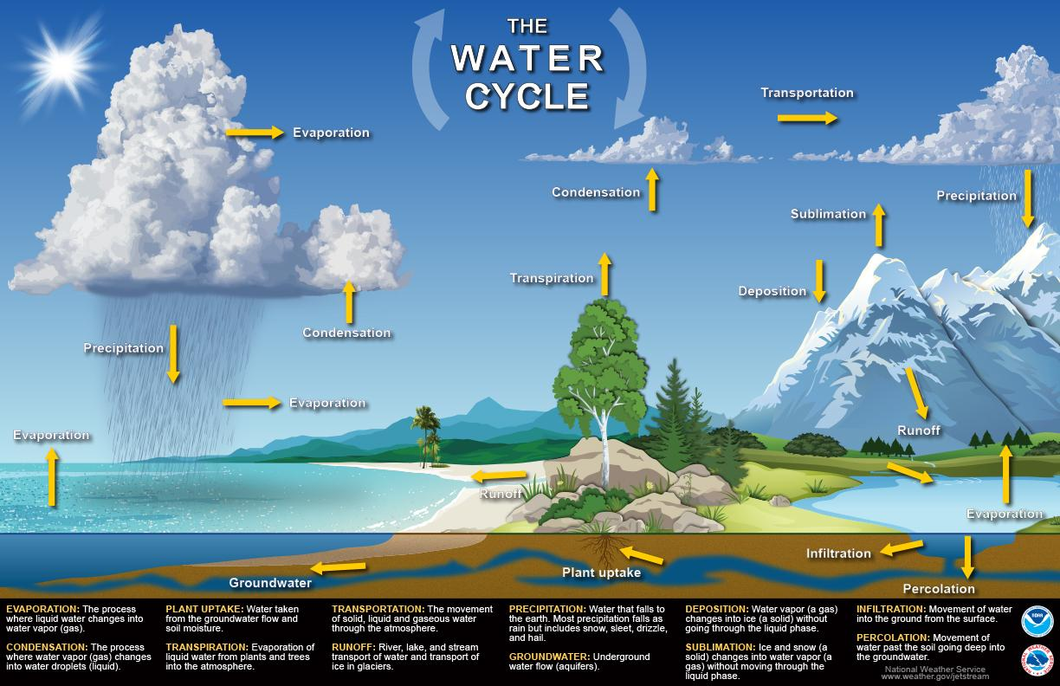
    - 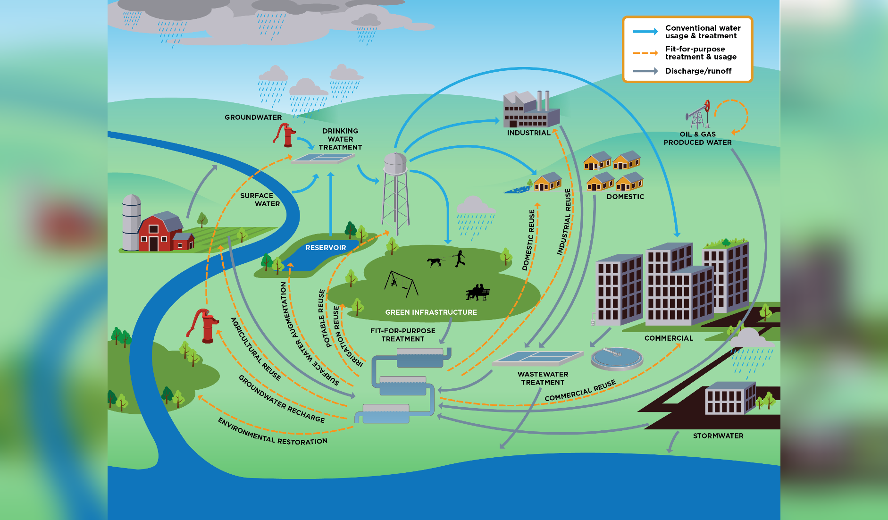
      - Transpiration- out of plant, via evaporation from leaves/stems/flowers
      - Infiltration- movement water into soil from surface
      - Percolation- movement water through soil
      - Sublimation- solid to gas directly
      - Runoff- water moves over land into bodies of water
- Freshwater distribution
  - Precipitation
    - Main input into freshwater system
    - Precipitation formation
      - evaporation-> cooling-> condensation-> precipitation
      - Rain- main source of freshwater, directly replenish bodies of water
      - Snow- freshwater reservoir, release liquid water gradually as melting, changes based on water availability
      - Hail, sleet, freezing rain also include in precipitation
      - Rapidly snow melt-> flood

- Precipitation controls
  - Precipitation needs- cooling and water
    - Cooling- cause condensation-> water vapor better held in warmer air, cooling forces water vapor out becoming liquid water
  - Orographic lift- mountains, cooling happens due to change in elevation-> wind blows over mountain range-> goes over mountain, higher elevation cooler (less air pressure, lower density, holds less heat)
    - Adiabatic cooling- due to elevation changes
    - Diabatic cooling- direct transfer of heat
    - Varied water sources-> condensation rain on windward side, dry on leeward side of mountain (down air)-> creates rain shadow (down wind side very dry, all the water rained out on other side mountain-> etc west side US)
  - Continentality- regions in large continents very isolated from bodies of water can’t have much precipitation (gobi desert asia)
  - Lake effect- downwind side of lake lots of precipitation, cold air passes over warm lake water (gains water) floats up
    - Cooling from changes in elevation
    - Great lakes-> dry northwest side, wet south east side
- Precipitation properties
  - Seasonality- some months have more precipitation than others, season patterns, changes during the year, how large difference between wet and dry season is
    - High seasonality- big difference between wet and dry seasons
    - Low seasonality- small difference between wet and dry seasons
    - Wet season timing depends on water availability
  - Intensity- rate precipitation is falling- depth/time
    - Higher intensity- more water at ground faster-> likely to have more run off and surface floor, cannot percolate easily
  - Spatial distribution- where precipitation most likey to fall
    - Globally-> latitude depends a lot, tropics have lots of rain
      - Warmer tropics- more evaporation- more rain, wind currents
    - regionally-> depend on topographics
- Aridity spectrum
  - Measure how much precipitation a region gets
    - Arid- not enough to support plants much, deserts, west us
    - Semi arid- supports more plants, grasslands, shrubs, mid us
    - Humid- lots of plants, forests, eastern us
    - Used to group regions-> affects with bodies of water can form
  - Stream types
    - Perennial- humid, always flowing
    - Intermittent- semi arid, strength depends on precipitation
    - Ephemeral- arid, temporary, only flow after rain, dries up eventually, dry river beds
  - Playas- dry lakes, used to be lake-> basin left large flat land, sometimes hold water after rain, semi arid to arid places
    - Evaporite deposits- salts that used to be dissolved in water, crust on ground, gypsum, calcite, humans use these materials
Drainage basin and streams
- watersheds - area of land where if water falls on any part of land-> all flows into the same body of water based on how land layout
  - Can label by which ocean, lake, small/large rivers, most common is major rivers, used to look at pollutant travels, where groundwater can be found
  - Parts of water shed
    - Basin
    - Watershed boundaries lined w high topography
    - Sub basins- smaller watershed for tributaries and streams
    - Mouth goes to final body- usually ocean
- Stream order- classify streams in a water shed
  - Stream- any flowing water, no matter size
    - Parts
    - Body of water- stream moving stuff around
    - Headwaters- source of water, top of mountain melting snow
    - lake/ ocean- mouth, not rlly moving much, going down stream
    - Tributaries- smaller streams/rivers flow into larger
    - Confluences- where smaller streams meet bigger
  - Stream order- numbering system to classify systems, by how much they branch (how many tributaries and where), how main they are to the system
    - Classic stream order/ Hacks/ Gravelius- start number at mouth/sea, biggest part to smallest, main river is largest number
    - Strahler stream order- start at smallest tributary build up, if diff numbers merge, next stream given same number as the higher of the 2 tributaries, mouth is largest number, 1+2=2
    - Shreve stream order- 1 is smallest tributary, confluence is sum of two rivers flowing into it, 1+2=3, doesnt always have every number
- Drainage patterns- patterns streams and tributaries form in, geometry and shape of watershed, tells us abt geologic environment
  - Types
  - Dendritic- branching tree roots, homogenous bedrock
  - Parallel- streams and aligned, pronounced slope/elongated landforms, valleys and cliffs
  - Trellis- one main stream w small tributaries, tomato grids, folded topography (tectonic)
  - Rectangular- tributaries form at right angles, faulting (crack in rock, tectonic)
  - Radial- tributaries move away from central location, conical features
  - Centripetal- opposite of radial, streams flow inwards, depressions/basin/lake
  - Deranged- no clear pattern, crazy, interruption of older pattern, used to have radial but then something happened, catching transition phase between two drainage patterns
River sediment and channels
- Channel types
- Planform- river geometry, many common types
  - Straight- straight, steep landscape, parallel sorta
  - Meandering- river bend, curvy, flat topography, dendritic sorta, speeds up erosion/deposition, most common
  - Braided- looks like a bunch of rivers but they are all in same channel, has sediment bars in the middle, areas with lots of sediment-> gets picked up and dumped, sediment bards always moving downstream
  - Anastomosing- large vegetated sand bars, bars are more permanent than braided, roots and trees keep bars in place
- Sinuosity- how curvy is stream
  - Sinuosity index= channel length/ downvalley length
    - Larger number- higher sinuosity, very curvy
    - Lower number- lower sinuosity, less curvy
    - Straight (less than 1.1) <sinuous (1.1-1.5)<meandering (more than 1.5)
- Sediment properties- how sediment in river changes
  - Sediment rounding- how round/smooth one grain of sand is
    - Very angular, angular, sub angular, rub rounded, rounded, very rounded
  - Sediment shape- how uniform diff dimensions are
    - Low (inconsistent uniformity) or high (very uniform) sphericity
  - Sediment size- how large is individual grain is
    - Wentworth scale of classification, diameter
    - Smaller grains easier to transport
  - Sediment sorting- group of sediment, similarity measure looking at size
- Sediment properties along a river, headwaters-> mouth
  - Smaller grains are transported easier-> goes farther
  - All grains broken smaller, chip angular parts, becomes more round, more spherical, better sorted
    - River selects particles that are more similar, segregating
- Sediment transport
  - Hjulstrom diagram
    - Flow velocity vs wentworth scale sediment size
    - Fastest flows eroded sediment the most, looks at river bed as benchmark
  - Modes of sediment transport, depends on size and composition
    - Suspension- clastic (non dissolved), suspended via water movement/floating, not touching riverbed, finer grains (lighter so easier to suspend), clay
    - Solution- dissolved load, minerals dissolved in water, salts
    - Traction/ Bed load- clastic, supported by riverbed, moves via rolling
    - Saltation- jumping, mid between suspension and bed load, bouncing along riverbed
  - Competence- max sediment size that can be transported by stream, component or incompetent for given size, can see what types of sediment is found where
  - Capacity- max amount of sediment of given size a stream can transport as bedload
    - Based on channel gradient (steeper channel carries more-> faster water), discharge (how much water is moving, more discharge carries more water-> faster), grain characteristics (size, angularity, sphericity, roughness-> affect friction and movement of bed load)
  - Supply- amount of sediment available
    - Look at specific size, can limit competence and capacity
    - High slope, supply limited, large grain size
    - Low slope, transport limited, smaller grain size
- Bedforms- features formed on riverbed when water and sediment interact
  - Ripples- small undulations/waves on bottom of bed, initial bump-> sediment go up and over bump-> eroded into deposit, slowly migrate downstream, eroded from stoss side (gradual slope)-> deposit onto lee side (downstream, steeper slope), creates cross bedding (slanted sections inside individual ripples due to deposition, top eroded off and deposited, can tell current direction
  - Dunes- larger ripples, sediment eroded upstream gradual, deposit downstream steep, migrate downstream, can tell current direction
  - Antidune- reverse dune, sediment deposit upstream, eroded downstream, flow conditions of stream are different (speed, depth, motion), migrate upstream, form in faster flow water than dunes, different current patterns, more symmetrical than dunes
  - Bars- elevated region of sediment deposited when current slows down, different types
    - Mid channel- similar to braided stream, river flattens-> sediment deposited in center chunk, tiny island like
    - Mouth- at mouth of streams, slow down to deposit into large body water, needs to push against ocean, lots of sediment deposit, deltas
    - Point- meandering river slows to bend, deposit sediment on inside of curves
Fluvial geomorphology (shape of rivers)
- Stream profile
  - Stream gradient- how steep stream is, slope=rise/run
    - Base level- lowest level stream can erode to
      - Local base level- region of stream due to geology in location, cant erode past there (etc resistant bed)
      - Ultimate base level- sea level, lowest any stream can go physically, can't erode any lower than mouth
    - Profile- shape river takes cross sectionally, always trying to reach base level, similar simplified profiles. Steep gradient at head-> longitudinal stream profile-> gentle gradient near mouth
- Erosional processes
  - Erosion- transport sediments away from original source, (wind, water, etc)
    - Downcutting- erosion by river cuts down into rock-> V shaped valleys, deepens channel
    - Gradient- steeper gradient-> faster water flow (faster erosion and downcutting, less deposition)
- Equilibrium- any change will cause stream to return to steady state, return to same profile (most energetically favorable for river, needs time for the changes to occur), due to sea level change or land elevation change
  - Graded stream- idealized profile for stream, steady state, ideal gradient to not cause additional downcutting or deposition, smooth concave profile
  - Sea level drops-> gradient steepens, downcutting until stream mouth reach new base level
  - Sea level rise- gradient flattens, less erosion-> more deposition
- Erosional landforms
  - Knickpoint- sharp break in slope in river, often have waterfall (smooth, DROP, smooth), form cuz of geomorphology/gradient changes-> adjust to changes, kickpoints erodes upper rock region more than lower, migrates upstream-> helps stream adjust to new gradient
    - Fault- crack in rock, moved up due to smt that broke
    - Lithologic contact- gradient changes
  - 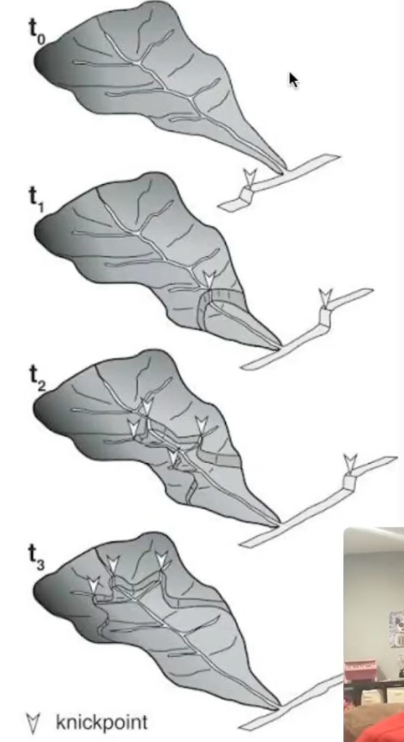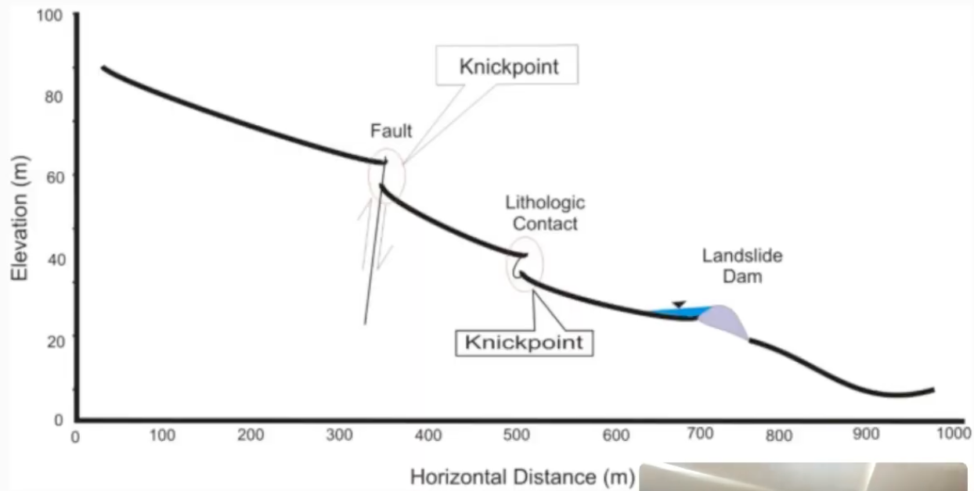
  - Depositional landforms
    - Gradient of stream flattens out/closer to mouth-> water slows down-> deposit sediment
    - Floodplain- flat area land surrounding a river, floods during heavy rain/high discharge-> water flattens out and slows down-> sediment gets deposited in flood plain
    - 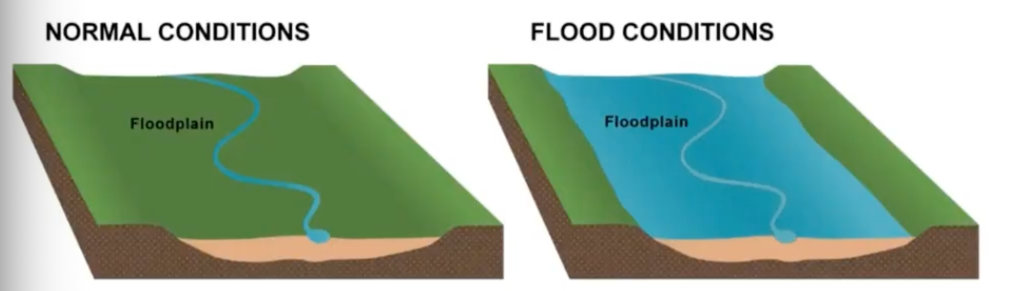
    - Natural levee- raised edges on a stream, from deposition sediment from flood, part closest to river is tallest part of levee and has coarsest sediment, move away from river levee flattens out and more finer sediments like clay or silt cuz lower energy
    - 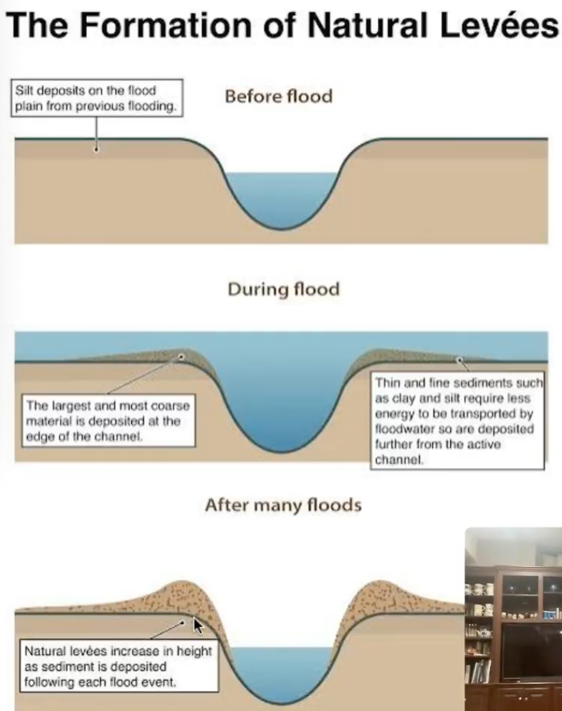
    - Delta- triangle of sediment, mouth of river, stream emptying into still body of water, pushes against motion-> drops all the sediment, coarser sediment closer to river cuz higher energy, finer sediments farther cuz lower energy
    - Alluvial fan- triangle sediment, stream moves from steep to flat ground, mountain plain-> flat land, coarse-> fine sediment
- Meandering rivers
  - Curvy, high sinuosity
  - Water wants to go straight cuz of momentum and inertia
  - Hitting bank-> curves sharply-> slowest
  - Flow fastest at outside of bend
    - Erosion on outer edge, deposition inner edge
  - Point bar- deposited sediment on inside of meander
  - Cut bank- eroded cliff on outside of meader
  - Oxbow lake- overtime meander gets larger, river almost makes circle-> erosion breaks thru wall, river continues straight-> lake breaks off
- Paleohydrology
  - Looking at landforms preserved in rocks-> learn abt past water features
  - Can learn: where was water, which way was up, which way did water flow?
  - Cross bedding- slanted layering cuz of streamflow, used to have water, formed in dunes/ripples in streams, whichever side of crossbedding is truncated-> was up
    - Sediment deposited, top is truncated (sediment deposition suddenly stop when river dried up), bottom and tangential (sediment slowly deposited)
    - Current flowed in way bed oriented (wind/water carries grains-> grains pile up on top of crest-> pile gets too high grains fall down front-> repeated avalanches make many layers that are preserved as cross bedding
  - Ripple marks- preserved ripples
  - Raindrop imprints- rain strikes sediment and leaves crater
  - Mud cracks- arid environments when mud dries
  - Graded bedding- sorting and change in sediment size within a bed-> deltas/alluvial fans
Streamflow
- Discharge- volumetric flow rate, how much volume of water is moving thru place per time
  - area= depth x width
  - discharge= area x velocity river, Q=AV
- Manning’s equation- estimate avg discharge of stream
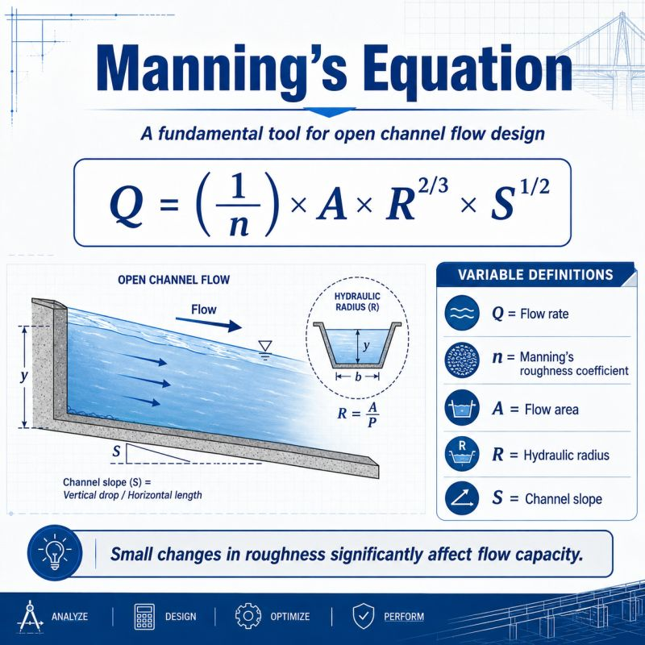
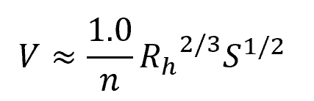
- n- roughness coefficient, how easy can water flow in stream
- A cross- cross sectional area
- Wetted perimeter- length of channel bed water is in contact with
- In wide streams- hydraulic radius-> approximate using depth
  - Deeper channel- better flow, less friction
- Can substitute in discharge

- Chezy’s equation- estimate avg flow velocity
- 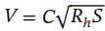
  - V- avg velocity
  - C- chezy’s constant (experimentally determine value for a river, calculate factors that might change/influence flow of river)
  - R- hydraulic radius (in widestreams, approximate using depth)
  - S- gradient, slope
- Floods- water overflows from river onto normally dry land
  - Common in flood plains near rivers, extreme flood can move out of floodplain
  - Causes: heavy rain (lots of runoff), melting snow/ice during spring
  - Flood frequency- how often a flood will affect a certain area, how often certain magnitude of flood will occur
    - Recurrence interval- probability a flood of given strength will occur within given year, no guarantee it actually happens once within that interval
    - Depends on rainfall, how much sediment, shape of river
Groundwater
- Ground water- water beneath surface, pore spaces within soil/rock, seeps downward slowly (gravity, percolates)
  - Residence times up to 10000 years, not stationary
  - Subsurface zones
    - Saturated zone- all pore spaces entirely full w groundwater, lowest level in earth, basically like a lake
    - Zone of aeration- some empty pore spaces, closer u get to groundwater-> fuller pores
    - Capillary fringe- peaking out water from saturated zone, left over
  - 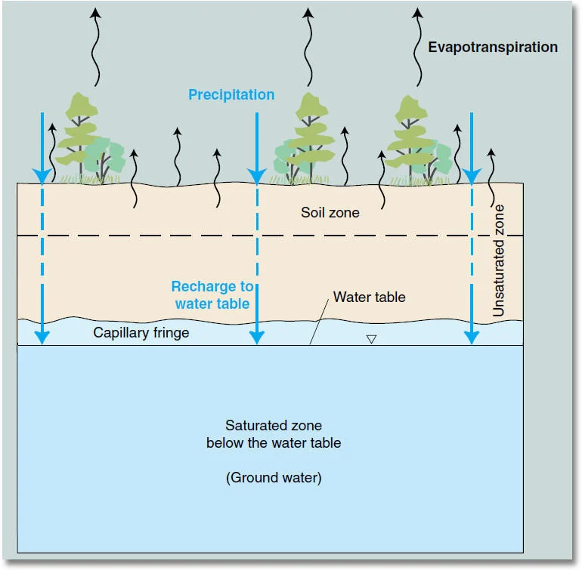
  - Water table- top of zone of saturation (below is filled pores, above is empty pores), when intersects w surface-> water comes out-> forms spring
- Darcy’s law- describe flow of water thru pores (groundwater)
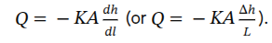
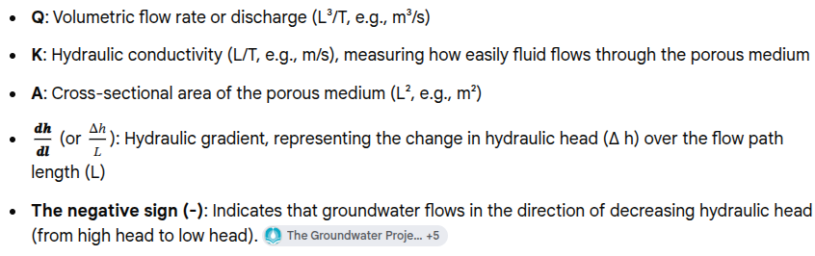
  - Volume moving thru specific place
  - K- permeability, how well ground lets water pass through
  - Mu- viscosity, how easily liquid flows
    - Water has low viscosity, olive oil med viscosity, honey high viscosity
  - L- length distance flow is being computed for
  - Change in pressure- how much the water is being pushed down between start and end of flow, change in water depth, greater change in pressure (water moves faster, getting pushed down more)
- Aquifers- underground layer of permeable rock (fractured rock, sediments), can store and transmit groundwater, sand and gravel
  - Aquitard- stores and transfers water less than aquifer, sandy clay and shale
  - Aquiclude- stores water, no transfer, clay
  - Aquifuge- no storage no transfer, granite
  - Unconfined aquifer- most basic type, below aquifer has aquiclude or aquitard (these prevent/slow down water, keeps it stored), no impermeable layer on top, water directly exposed to atmosphere (zone of aeration), water table phreatic aquifers, direct recharge from surface, vulnerable to contamination
  - Confined aquifer- have impermeable layer on both top and bottom of aquifer, not very accessible to humans, high pressure
  - Artesian aquifer- surrounded by layers of impermeable rock, orientation of layers-> pressure on aquifer, (tilted layers of rock), water naturally comes to surface, good for human drinking water
- Karst
  - Carbonate rocks- any rocks made w minerals that have carbonate CO3, limestone/marble/dolomite, soluble in water
    - Water dissolves carbonates- slightly acidic when carbon dioxide in water (carbonic acid), acidic water reacts w carbonate minerals
  - Karst- topography formed when carbonate rocks dissolve in water
  - Caves- underground open spaces, stalagmites/stalactites (mineral is dissolved in water, evaporation leaves minerals behind), cave keeps getting bigger cuz more water is getting dissolving and diverted
  - Sinkholes- depressions, form in diff ways: (collapse cave, river erode into soluble rock, insoluble rock lies on top of soluble rock and eroded into caves)
  - Solution valley- like a river valley, large circular chunks, formed when multiple sinkholes join together, river dissolved thru walls between sinkholes and joined them tgt
  - Disappearing streams- streams that flow into karst caves/depressions, loses water along the streambed, flows into cracks in the rock
  - Springs- groundwater reaches surface, humans can use without drilling, karst spring (form within soluble rocks, karst topography, groundwater eroded hole into rock-> water comes out), form due to high pressure, can dry up in periods w little precipitation, sometimes fickle
Bodies of water
- Lake formation
  - Tectonic lake- movement of plate/crust/rock
    - Faulting- crack in rock due to stress, topography changes, rocks move down (move pools)
    - Titling- continental collision bends rock layers-> depression
    - Folding- bend and curve landscape
    - Rifting- most common, continent splits into 2, depression in middle-> chain of lakes along rift zone (east african rift zone, baikal rift zone), rifting in western US as well
  - Volcanic-inside craters or calderas inside volcano-> blow off rock and depression holds water, caldera lake (crater lake in oregon)
  - River damming- river deposits sediment quickly enough to block the channel, lake forms behind dam
  - Glacial- glacially carved rock basins (ice moves forward, grinds rock, melts and moves backwards), dams formed by glacially deposited sediments, created Great Lakes
- Chemical properties
  - pH- potential for hydrogen, measures concentration of hydrogen ions in a solution, acidic (lots of hydrogen), alkaline/basic (not much hydrogen, reacts to remove hydrogen ions from solution), scale 0-14, logarithmic scale each number is 10 times stronger than last number
    - Affects biological activity, organism health, enzyme function
    - Chemical solubility
    - Toxicity of metals and pollutants, changes how easily gets into water and organisms
  - Alkalinity- how resistant body of water is to changes in pH, buffering capacity, higher alkalinity-> more resistant to changes in pH, depends on dissolved ion concentrations (carbonate/CO3 2-, bicarbonate HCO3 -, hydroxide OH-) come from weathering cuz these can accept or donate hydrogen ions, keeping pH stable helps protect lake
  - Dissolved oxygen (DO)- measured in mg/L or ppm, essential for fish and other aerobic organisms, indicator of water quality and ecosystem health
    - Temperature changes, lower temp= higher DO
    - Atmospheric pressure, higher pressure= higher DO, more pressure squeezing oxygen into water
    - Salinity, higher salinity= lower DO, more salt-> less space for oxygen
    - Solids in water, more solids= lower DO, less space for oxygen
    - How DO enters water: diffusion from atmosphere, aeration (wind/waves, water flowing over rocks and debris), photosynthesis from plants in water making oxygen, most DO at top of water
  - Biochemical oxygen demand BOD- how much oxygen is needed by microbes to break down organic stuff in water, higher BO=less oxygen for fish= bad, lower BO= healthier water= good
- Organic waste enters water
- Microbes break it down
- Microbes use up DO
- DO drops-> fish struggle to breathe
- Too much BOD= ecosystem collapse
- Physical properties
  - Turbidity- how cloudy/hazy in water due to number of particles, high suspended load-> increase turbidity
    - Seasons- more melt water/fresh water-> clearer water less turbid
    - Lake turnover- mixing lakes from natural processes-> pulls sediment up from bottom
    - Gasoline and oil- humans dumping stuff
    - Benthic organisms- live in bottom of lake
    - Urban runoff- humans introduce stuff to environment
    - Effects of turbidity- higher water temp, darker (absorb more light, hotter), lower photosynthesis rate (blocks light availability-> less growth), fish can't absorb DO thru gills, bacteria benefit-> more nutrients in water
  - Temperature- water colder at higher altitudes (thinner air and lower atmospheric pressure to retain heat properly), water colder at higher latitudes (farther from equator-> less direct sun angle), climate change-> warming up
    - Organisms have specific temp range- temp dictates species ranges, as temp changes species change-> invasive species, movement natives, movement economically important species
    - Solubility- water hotter-> gas less soluble (more kinetic energy breaks bonds between molecules easier, allows more DO to escape cuz moving faster), oxygen (aquatic organisms need to breather), carbon dioxide loss and changes: (carbon sequestration, photosynthesis, positive feedback loop harming environment)
    - Rate of chemical reactions- higher temp/kinetic energy-> more chemical reactions, more dissolved nutrients at higher temps (algal blooms, changing species composition)
    - Water density- thermal expansion (sea level rise, cooked if your on the coast), affect water movements (stratification)
- Stratification- layers of water w diff densities, diff layers settle in predictable way
  - Density based on temp (changes volume, thermal expansion) and salinity (changes mass)
  - Salinity doesn't vary much in freshwater, main factor changes density-> temperature
    - Epilimnion- top surface layer
    - Metalimion- middle density, thermocline (rapid temperature change, gets cold very fast), pycnoline (rapid density change)
    - Hypolimnion- deepest, most dense, 4C deg (most dense)
  - Seasonal stratification: diff times vary in solar radiation-> change temp and density of top layer
    - Overturning- top layer and bottom layer exchange places due to changes in density and mix
    - Free vertical mixing- whole lake similar/same densities- free to move around and mix
- 4 main patterns of mixing
  - Dimictic lake- 2 overturning events a year, once in fall once in spring, most common in midlatitudes, four distinct seasons, (in summer epilimnion gets very hot from sun-> gets cooler in fall and more similar density as metalimion and hypolimion-> mix deeper, cooling winter-> top gets very cold and colder than bottom layer-> sharper stratification)

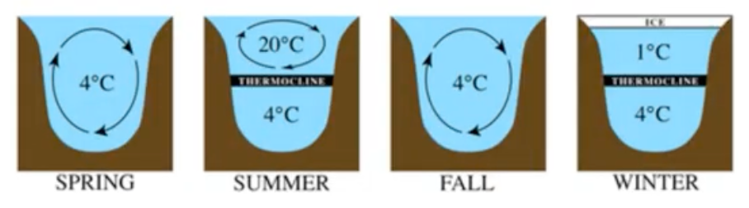
- Monomictic lakes- one mixing event per year
  - Cold monomictic- ice covered in winter, top layer never gets very warm (always below 4 deg C, free vertical mixing during summer), polar regions
  - Warm monomictic- top layer never gets very cold (always above 4 deg C), free vertical mixing during winter, tropical/temperate regions near equator where its warm for most of the year
- Polymictic lake- mix many times a year, never develop strong vertical stratification-> too shallow, tropical regions
- Oligomictic lake- mixes less than once annually, irregular/sporadic, weak mixing, tropical regions, needs lots of high temp and sun, least common
- Mixing important- transport critical nutrients and DO-> important for life, surface organisms need nutrients, benthic organisms need oxygen
- Waves- caused by movement, disturbance
  - Waves transport energy but not water, molecules move in orbits (circular motion)
  - Deep water wave- if depth is greater than ½ the wave’s wavelength, does NOT interact w ground
  - Transitional wave- if depth is between ½ and 1/20 of wave’s wavelength
  - Shallow water wave- id depth is less than 1/20 of wave’s wavelength-> shallow enough where ground has big impact on how wave moves and interacts, orbits get smushed-> less space for water molecules to move
  - Wave formation
    - Has disturbing force- creates energy thats getting transported, usually wind (pulls water)
    - Restoring force- tries to flatten what, usually gravity
    - Capillary waves- aka ripples, very small wavelengths, <1.77 cm, formed via water and small wind (disturbing force), water itself (restoring force)
    - Wind waves- basic waves, formed when wind blows over surface (grow from capillary waves), factors: fetch (distance wind blows), wind duration, wind strength
  - Shoaling- wave enters shallow water, friction starts to act on eave base (wave slows down) wavelength gets smaller cuz compressed from resistance, wave height increases to maintain energy
- Wetland- ground is flooded/saturated, earth gets completely wet and water one top is also there, permanently or seasonally flooded, fresh/brackish/saltwater
  - Create flat/enclosed area, need water source (usually flooding coasts), or overflowing onto floodplains, or glacial action (scrapes)
  - Classification
    - Dominant vegetation (what type of plants live there)
    - Water source (fresh, salt, brackish, flooded, stream)
  - Swamp- woody vegetation, trees/shrubs, varied water source
  - Marshes- herbaceous vegetation, reeds/cattails/sedges/grasses, varied water sources
  - Bogs- water source is rainfall or meltwater, some groundwater, forms peat (partially decaying organic matter, smushed into bottom of water, can be used at energy source can be burned as fuel)
  - Fens- water source mineral rich ground/surface water, forms peat
Human impacts
- Water extraction
  - Wells- main way to access groundwater, dig into aquifer (place pipe and get water out)
    - Artesian well- pressure pushes groundwater to surface
    - Water well (need to physically pull water up)- confined/unconfined aquifers
  - Aquifer depletion- groundwater infiltration is REALLY SLOW, remove faster water than recharging-> removes water, most aquifers in US being depleted (bad in southeast and midwest great plains region, mostly agriculture places)
  - Land subsidence- if enough water is removed-> ground falls down, land subsides, indonesia is struggling w this (mostly near coast, aquifer depletion causing land to fall-> flooding from coast-> pushes down on land more)
- Pollution
  - Point source pollution- easily identifiable source, a specific factory/one specific oil ship leaking
  - Non point source pollution- diffuse contamination, does not have specific source, runoff is contaminated
  - Biomagnification- as move up a food chain, concentration of toxin increases (organism high up food chain eats more-> adds more toxins into body-> concentration increase)
  - Bioaccumulation- gradual buildup toxins in one organism over time, eating/breathing more and more toxins inside body
  - Eutrophication- increase of nitrogen/phosphorus (farming, fertilizer), harmful algal blooms-> blocks sunlight since floating on top-> prevents lower level plants from getting sunlight-> kills plants, algae eventually dies off-> decomposition occurs-> depletion of oxygen DO (anoxic zone)-> fish kills
    - Short run increase oxygen due to algae, in long run decrease oxygen cuz oxygen depletion from decomposition
- Rivers on a topographic map
  - Topographic map- contour lines to show elevation
  - Rivers- create V shapes on map-> due to downcutting/ river channel, points upstream towards head water away from mouth, look at way tributaries join together (point in direction of flow)
- Hydrographs- way of measuring streams, displays discharge over time
  - Look at flow changes, tells us about changes in the environment, see how rainfall influences flow, base flow-> groundwater derived (natural flow), storm flow-> rainfall derived
  - Sections of hydrograph
    - Rising limb- discharge increasing because of rain
    - Peak discharge- highest flow rate/discharge
    - Falling limb- discharge decreasing, returning to base flow
  - Lag time- time between max rainfall and peak discharge, takes some time for river to adjust to water, some water falls into watershed as well so takes some time to all go into river

